**PROTRACTOR**

**DEBUG ON VISUAL CODE GUIDELINES**

INCONTACT

*Created Date: October 12, 2018*

*Created By: LogiGear Team*

1. **Setting for Debug mode**

* Open pakage.json
* Modify “scripts” value

"scripts":

{

"webdriver-update": "webdriver-manager update"

}

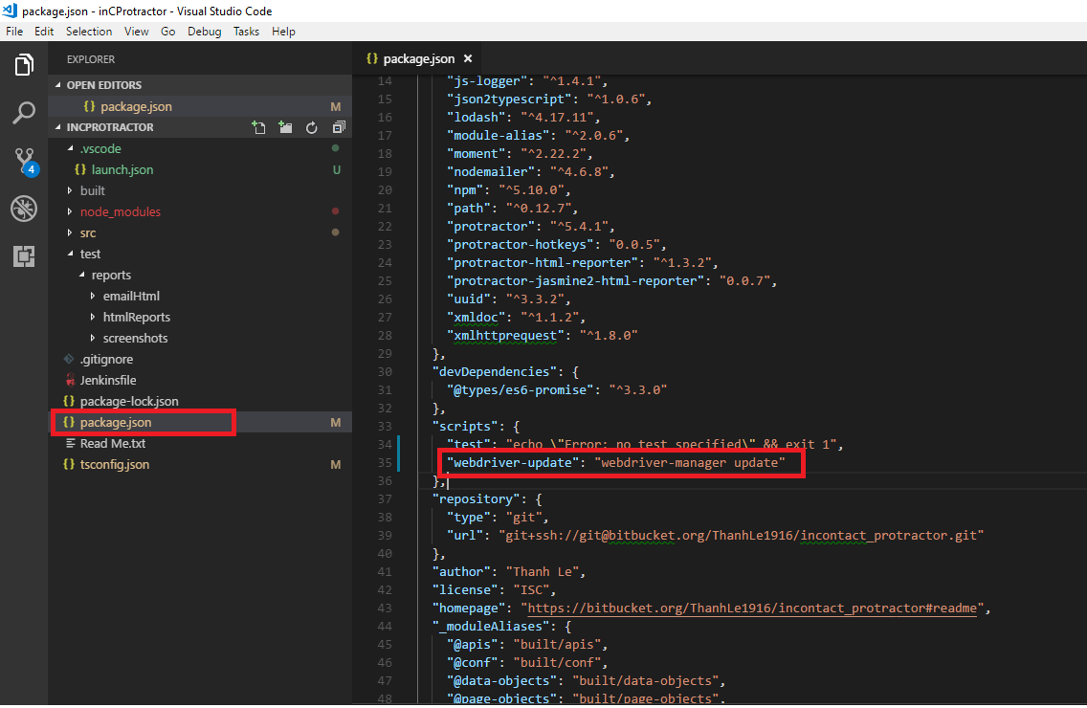

* Open tsconfig.json
* Set “sourceMap” value as “true”

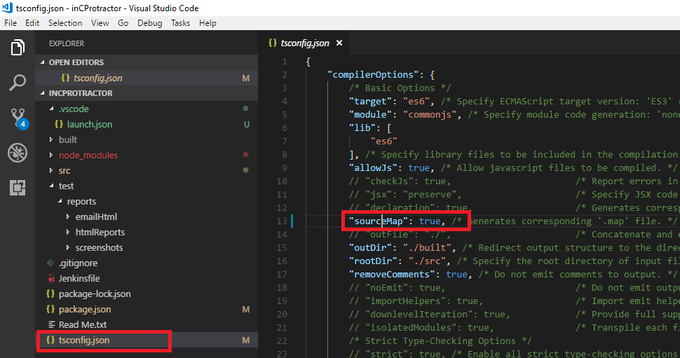

* **Select Debug icon on the left menu** (Ctrl + Shift + D )

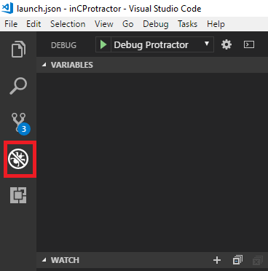

* **Click debug setting icon to open launch.json**
* **Edit file launch.json**

“name”: “Debug Protractor”,

“type”: “node”,

“stopOnEntry”: false,

"program": "${workspaceRoot}/node_modules/protractor/bin/protractor",

"args": ["${workspaceRoot}/**{file path}**"],

“preLaunchTask”: null,

“outFiles”: [“${workspaceRoot}/**/*.js”]

**Note: {file path} is the file path of configure file (.js) (For example: conf-smoke-test.js or conf-smoke-automation-orange.js) which declares the test case you want to debug in specs section.**

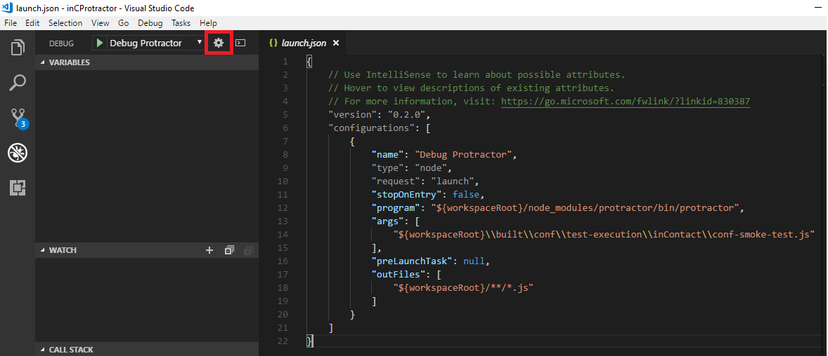

1. **Debug**

* **Open test case**
* **Mark some break points on the left of test steps**

**Note: Remember compile the code by “tsc” command after marking break points**

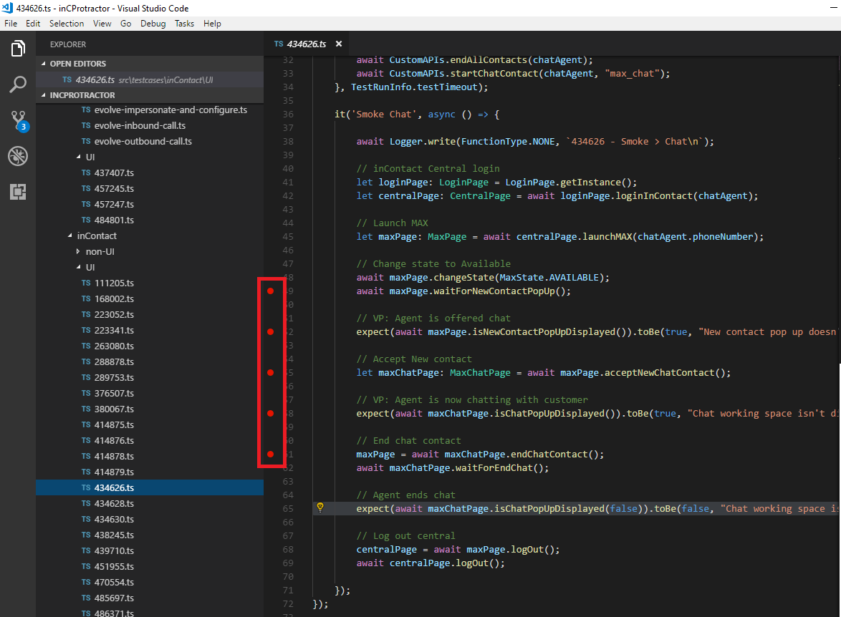

* Back to Debug window then click the debug console icon (next to debug setting button) to open Debug console section (Ctrl+Shift+P)
* Then click play icon to start debugging (F5)

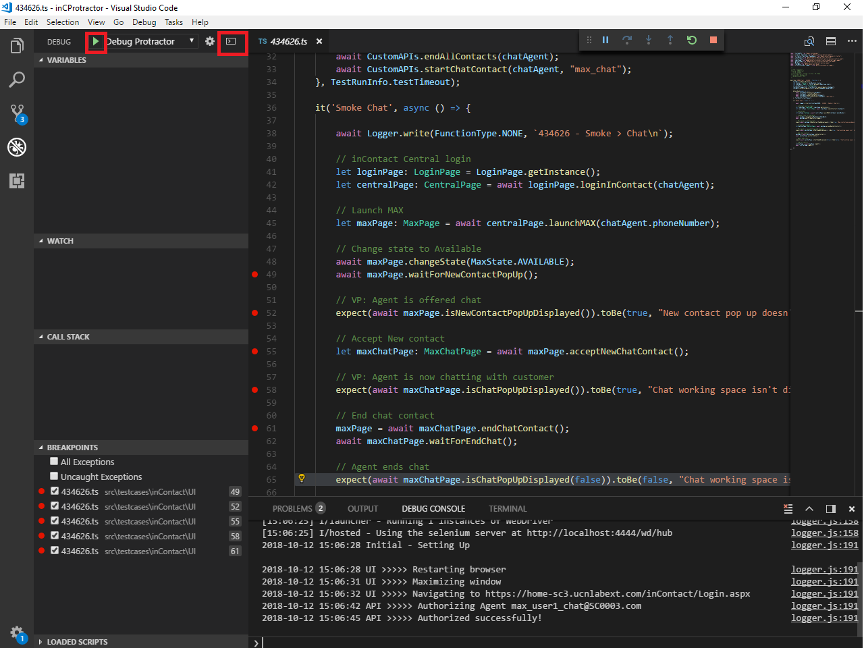

* Once a debug session starts, the **Debug toolbar** will appear on the top of the editor.

Debug Actions

* Continue / Pause F5
* Step Over F10
* Step Into F11
* Step Out Shift+F11
* Restart Ctrl+Shift+F5
* Stop Shift+F5